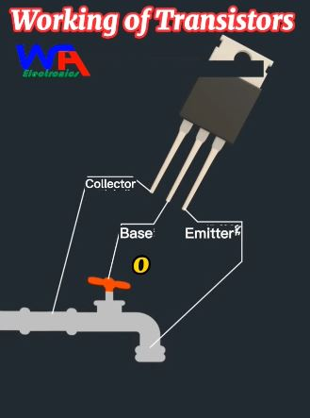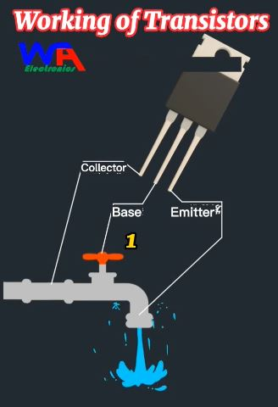

https://www.youtube.com/shorts/GmxdTW2a58o
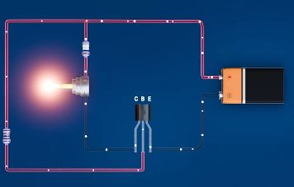

https://www.youtube.com/watch?v=uavMxwrgUQQ

